2026 PHYSICS PAPER II SHED MOCK
(40 Marks)
PROVISIONAL MARKING KEY
SECTION A (20 Marks)
- Describe an experiment to determine the density of cooling oil using Archimedes’ Principle.
Apparatus (2 Marks)
Any three of the following or correct diagram with labels
- Spring balance
- Solid sinker
- Measuring cylinder
- Cooking oil
- Water
- Thread/Hooker
- Eureka can
IF no diagram
- any two correct points =1 mark
- At least four correct points = 2 marks
IF diagram
- At least any three correct labels =1 mark
- Correct diagram = 1 mark

Procedure
- Suspend/hung a solid sinker from a spring balance and record its weight in air as W₁ /1
- Fill cooking oil to the brim into a eureka can /1
- Lower the sinker fully into cooking oil and record the new reading as W₂ /1
- Determine the upthrust on the solid sinker : Upthrust = W₁-W₂ /1
- Collect the displaced oil in a measuring cylinder and record its Volume, V. /1
- Weight of displaced oil =Upthrust
=W₁-W₂ /1

- Density of cooking oil(1) : D= ( W₁-W₂)/gV (1)
Alternatively, use Relative density
The same apparatus as above. /2
Procedure
- Measure the weight of the sinker in air, W₁ /1
- Measure the weight of the sinker when immersed in water, W_{w} /1
- Measure the weight of the sinker when immersed in cooking oil, W_{o} /1
- Loss of weight in water =W₁-W_{w} /1
- Loss of weight in cooking oil = W₁-W_{O} /1
- Relative density of cooking oil = (W₁-W_{O})/(W₁-W_{w}) /1
- Density of cooking oil = Relative density of cooking oil x density of water /1
Doil = (W₁-W_{o})/ (W₁-W_{w}) x D_{w}

= (W₁-W_{o})/ (W1-W_{w}) x 1000kg/m³ /1

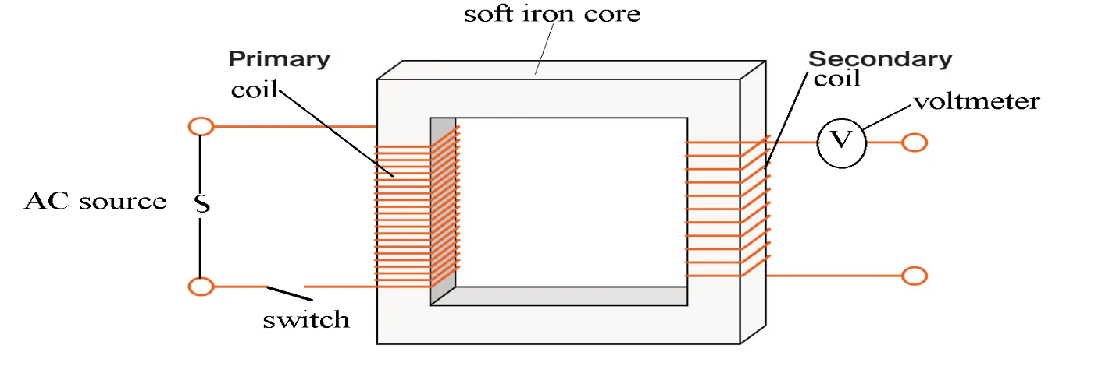Apparatus
- Two correct labels = 1 mak
- At least 3 correct points = 2 marks
- Correct diagram = 1 mark
Procedure
- Set up the apparatus as shown above
- Connect a secondary coil with a known number of turns /1
- Close the switch /1
- Record the voltmeter reading in the table /1
- Repeat steps b to using a different number of turns in the secondary coil. /1
- Compare values of number of turns with voltmeter readings /1
- If changes in n umber of turns in the secondary coil produces a change in the amount of induced emf, then number of turns affect induced emf. /1
- d.
- Object distance(U) cm | Image distance(V) cm | $$\frac{1}{U}$$ | $$\frac{1}{V}$$
20 | 60$± 5$
30 | 30$± 5$
40 | 25$±5$
50 | 21$±5$
3 marks 1 mark 1 mark
Column for V
- Two points within the range = 1 mark
- At least 3 points within the range = 2 marks
- Decreasing trend within range = 1 mark
Column for $\frac{1}{U}$
    - At least 3 correct points = 1 mark
Column for $\frac{1}{V}$
    - At least 3 correct points = 1 mark
3 g.
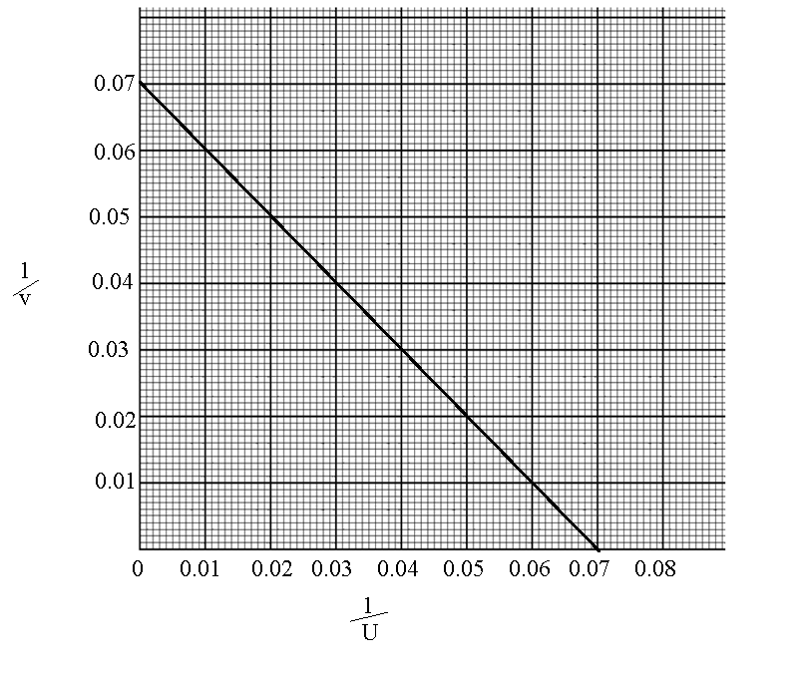
  - Correct labels on both axes = 1 mark
  - Correct scale on both axes =1
  - At least three correctly plotted points = 1 mark
  - Line of best fit which is linear and inverse = 1 mark
- 0.055 - 0.075 ( 1 mark)

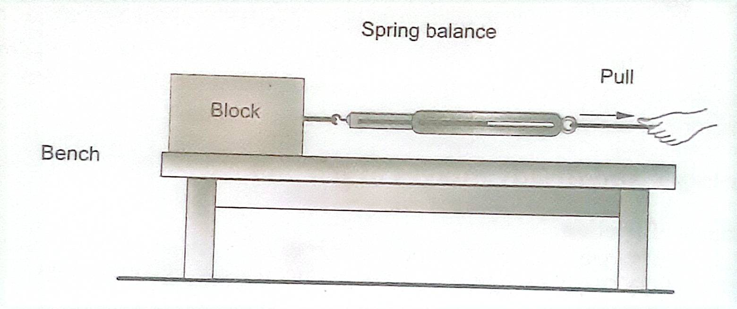
c.
Ramp | Spring Balance Reading (N)
X | $$<2N ( 1 mark)$$
Y | $$<1.5N ( 1 mark)$$

d. $U_{k}=\frac{spring balance reading}{normal reaction}$ /1
correct substitution / 1
correct value of $U_{k}$ /1
f.Same as 4d but using values of Ramp Y ( 3 marks)
g. $U_{k} for ramp X >U_{k} for ramp Y$ /1
h. $U_{k}$ depends on the nature of surface of contact, /1

